**Project Proposal**

**CodeCrakers: Competitive Programming Tracker Desktop Application**

Course: 0714 02 CSE 3104

Course Name: Software Engineering and Information Systems Project/Fieldwork

Course Teacher:  Dr. Kazi Masudul Alam,

Professor, Computer Science and Engineering Discipline,

Khulna University.

Proposed By:

Pranto Mondol (230211)  
Toma Rani (230221)  
Sobuj Chandra Paul (230231)

## Introduction:

The purpose of CodeCrakers is to provide a desktop application for competitive programmers to track, monitor, and improve their problem-solving performance across multiple online platforms. Users can link their platform usernames, view statistics, track weekly progress, manage offline problems, and edit their profiles. The system will also allow visualization of problem-solving trends and provide goal setting and reminders to enhance productivity.

## Use case:

* Register/Login – User creates an account for personalized tracking.
* Add Platform Usernames – User links Codeforces, LeetCode, AtCoder, etc.
* View Platform Statistics – System fetches and shows problem count, ratings, submissions, contests, etc.
* Track Weekly/Phase Progress – User views time-specific performance.
* Add Offline Problems – User manually enters custom problems with rating/topic.
* Filter & Search Problems – User filters by difficulty or tags.
* Export Statistics – Generate PDF/CSV reports.
* Receive Reminders – System sends contest/practice notifications.
* Edit Profile/Usernames – Update personal information and platform handles.

# Use Case Diagram

The following Diagram illustrates the key use cases of CodeCrakers and how the user, System interact with the app.

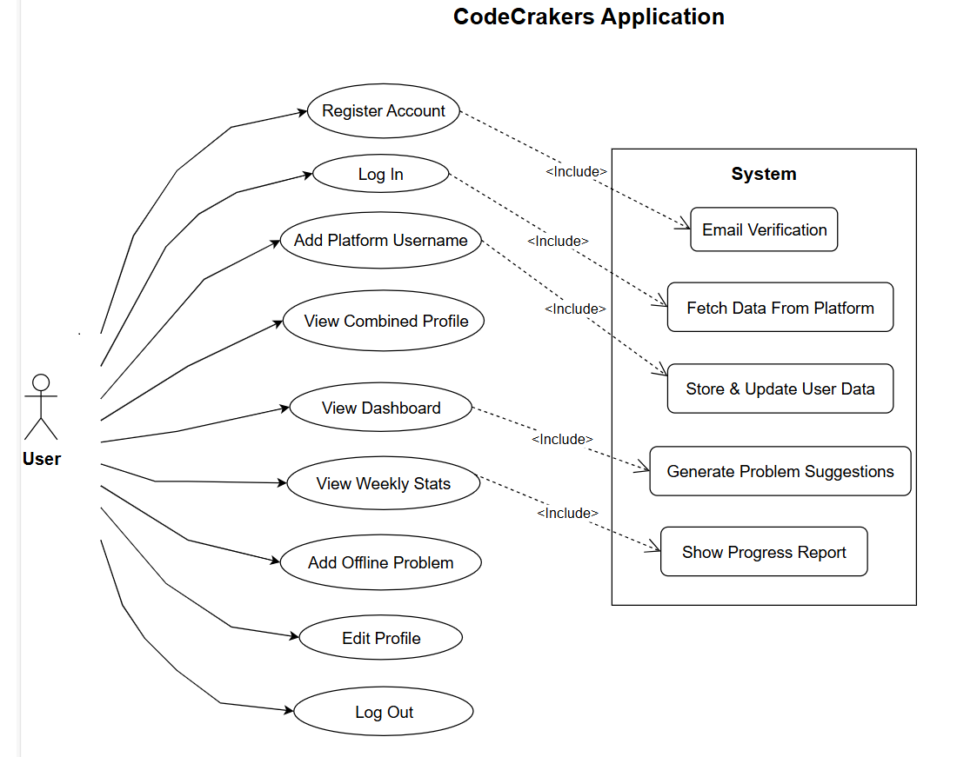

## Objectives:

* To develop a desktop application that consolidates competitive programming statistics from multiple platforms.
* To allow users to track weekly and phase-wise progress for self-improvement.
* To provide features for offline problem management, including rating assignment and tagging.
* To enable data visualization through graphs and charts for better insights.
* To support exporting statistics in PDF/CSV formats for sharing.
* To implement reminders and notifications for practice consistency.
* To ensure data security and offline availability.

## Discussion:

This system aims to modernize lab-based evaluations, especially in programming-intensive courses. It addresses issues such as manual evaluation delays, limited exam control, and unreliable online systems in environments with restricted internet access. By using a desktop-based solution over LAN, the system ensures low-latency communication and secure data handling. Real-time evaluation and leaderboard support make it ideal for both academic tests and internal CP contests.

## Features:

* User Authentication (Register/Login)
* Add and update platform usernames
* Auto-fetch statistics via APIs
* Visualize ratings, submissions, solved problems
* Weekly/Phase progress tracking
* Offline problems management
* Export stats as CSV/PDF
* Dark/Light mode UI
* Desktop notifications for reminders
* Secure data storage
* Cross-platform desktop support (Windows/Linux/MacOS)

## Requires Resources:

* Human Resources: 3 developers (team members).
* Hardware: Standard PC/Laptop with Windows/Linux/MacOS.
* Software Tools:
* Programming Language: C# (Windows Forms/WPF/MAUI).
* Database: MySQL.
* APIs: Codeforces API, LeetCode API, etc.
* Version Control: Git/GitHub for collaboration

## Required Technologies:

* Programming Languages: C# (Windows Forms/WPF/MAUI).
* Database: MySQL.
* Visualization: LiveCharts2 (for WPF/WinForms/MAUI in .NET), OxyPlot.
* API Integration: REST APIs of coding platforms.